Oracle APEX SQL Project
Sindhu Thapa
Department of Computer Science, King Graduate School
Course: 25FL-CS630-152HY – Database System
Professor Pritom Bhowmik

December 3, 2025

Oracle APEX SQL Project – Query Guide & Explanations

Introduction

The document contains the entire SQL analysis, which fulfills the requirements of the Oracle APEX Final Project. The database tables from the workspace allowed me to run all queries directly inside Oracle APEX. The primary objective of this project is to demonstrate expertise in fundamental SQL operations, including self-joins and cross-joins, as well as single-row and multi-row subqueries, and index creation for performance optimization. The document contains SQL syntax followed by detailed explanations of query operations and blank spaces for Oracle APEX execution screenshots after running each query. The combined results demonstrate effective SQL capabilities for data analysis, decision support, and the optimization of extensive database operations.

Query 1 – Employee & Supervisor (Self Join)
Purpose:
- Show each employee along with their supervisor.
SQL Syntax:
SELECT e.employee_id, e.first_name, e.last_name, s.first_name AS supervisor_first_name, s.last_name AS supervisor_last_name
FROM employee e
LEFT JOIN employees
ON e.supervisor_id = s.employee_id;ORDER BY employee_name;
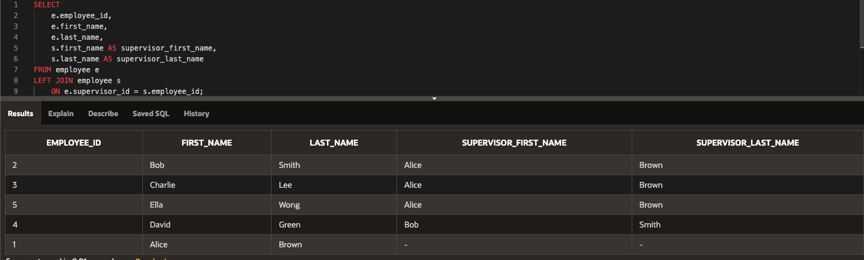
Explanation:
- The query displays each employee together with their supervisor's name.
- The query performs a self-join because the database stores employee and supervisor information in the same table.
- e = the employee
- s = the supervisor
- The join matches e.supervisor_id with s.employee_id

The Left Join operation enables us to retain all employees in the result, even those without a supervisor position, such as the CEO or top manager.

Query 2 – Product × Category (Cross Join)
Purpose:
- Generate all possible combinations of products and categories.
SQL Syntax:
SELECT p.product_id, p.product_name, c.category_id, c.category_name FROM product p
CROSS JOIN category c
ORDER BY p.product_id, c.category_id;
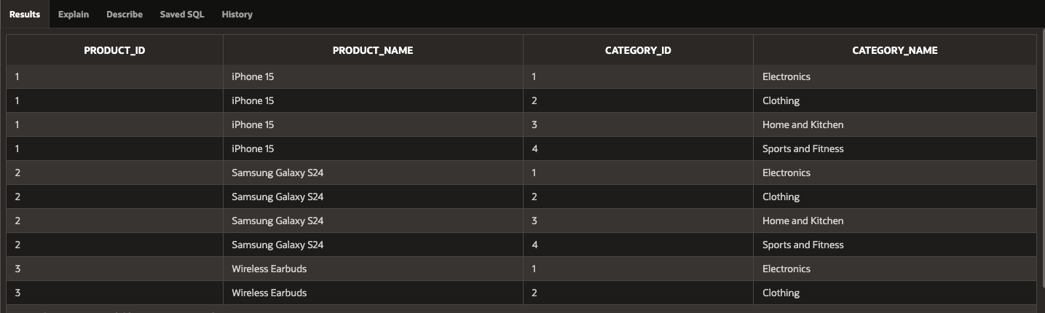
Explanation:
The query performs a Cross Join operation, which merges all products with all categories.
A Cross Join operation does not require a matching condition because it generates all possible combinations.
The query serves three purposes: it helps verify product-category relationships, generates sample catalogs, and determines the total number of database combinations.
The result will show:
- Product ID
- Product Name
- Category ID
- Category Name
Each product will appear only once per category.

Query 3 – Products Above Average Price (Single‑Row Subquery)
Purpose:
- Find products priced higher than the overall average.
SQL Syntax:
SELECT product_id, product_name, price FROM product WHERE price > (SELECT AVG(price) FROM product) ORDER BY price DESC;
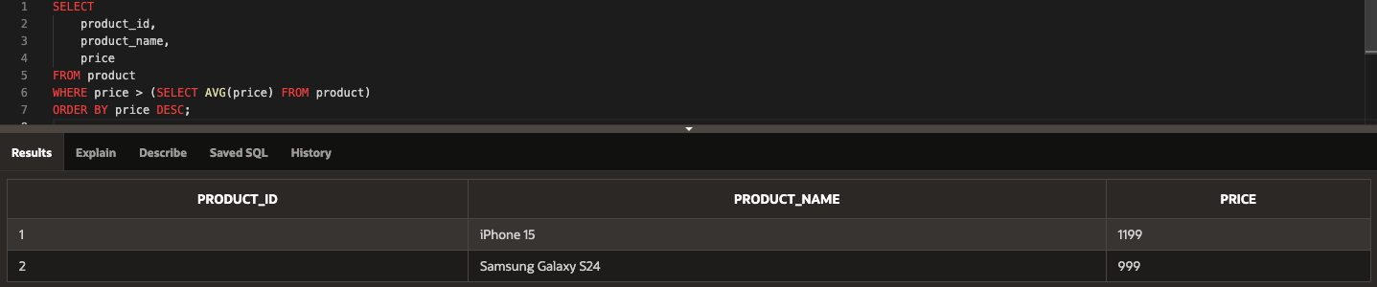
Explanation:
The query retrieves all products that have prices exceeding the total average price of all products stored in the database.
- The subquery (SELECT AVG(price) FROM product) calculates the average price.
- The main query returns all products where the price is greater than the average.
- ORDER BY price DESC shows the highest-priced items at the top.
This helps identify premium or high-value products in the catalog.

Query 4 – Products in High‑Price Categories (Multi‑Row Subquery)
Purpose:
- Show all products from categories with at least one product priced above 500.
SQL Syntax:
SELECT product_id, product_name, price, category_id FROM product WHERE category_id IN ( SELECT DISTINCT category_id FROM product WHERE price > 500) ORDER BY category_id, price DESC;
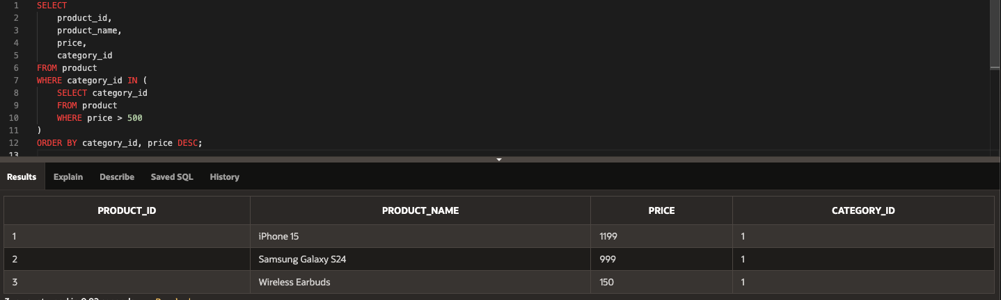
Explanation:
The query shows all products that exist in categories containing at least one product with a price higher than $ 500.
It works in two steps:
- The inner query:
- SELECT category_id
- FROM product
- WHERE price > 500
This finds all categories that contain expensive products.
- The main query then selects all products in those categories — not just the expensive ones.
This is called a multi-row subquery because the inner query can return multiple category IDs.
It helps analyze entire groups of products that belong to premium categories.

Query 5 – Create an Index on the PATIENT Table
Purpose:
- Improve search speed for large tables by indexing the LAST_NAME field.
SQL Syntax:
SELECT * FROM patient WHERE ROWNUM <= 5;
CREATE INDEX idx_patient_lastname ON patient(last_name);
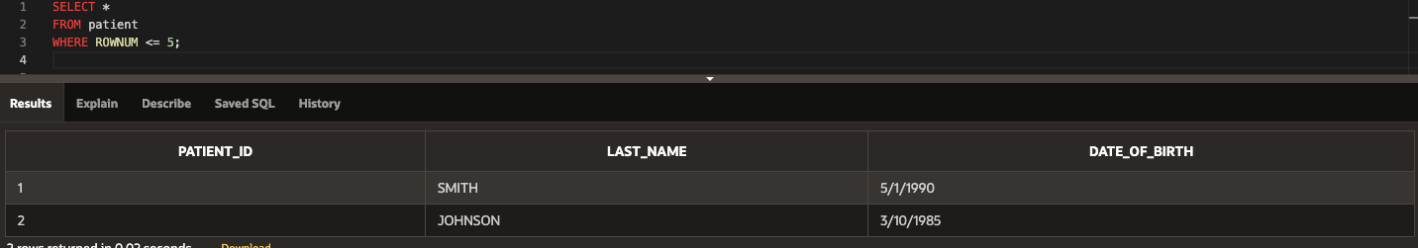
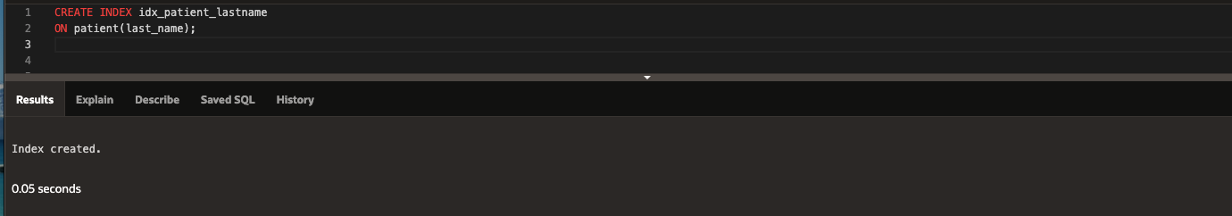
Explanation:
Large tables become searchable at high speeds through the implementation of an index.
The Patient table contains more than 100,000 entries according to this project, so queries that use last name search criteria will experience performance delays.
By creating an index on last_name:
- Oracle can quickly locate matching rows
- Instead of scanning the entire table, it looks in the index (like a book’s index)

